Overview
PowerFilter is an easy-to-implement datawindow filtering component that gives your applications auto-filtering functionality similar to that found in Excel 2010. It works with your existing datawindows, just add one control to your window and as little as 3 lines of Powerscript to implement.
Features
- Generates a dropdown checklist with unique values for each column. Check as many items in as many columns as desired to define the filter
- Includes a Custom filter dialog with pre-defined options based on datatype (Last Month, Next Month, Last Year, This Year, Greater than, Contains, Above Average, etc.)
- Supports grid and tabular datawindows , both columns and computed fields
- Supports all standard data types
- Supports custom column formats including format expressions
- Multilingual support built in, no coding required. A single .pbl supports multiple languages at runtime
- Dropdown Datawindows, ListBoxes, and Code Tables filter and sort on the Display value, not the data value
- Non Visual Object (NVO) implementation. Visual checkbox implementation also still supported for backwards compatibility
- DisplayAsPicture support. Dropdown and custom filter dialogs automatically display images to select/filter if the column displays images using the DisplayAsPicture property
- Appeon compatibility
- Conditional visibility support. Filter button for a column has the same visibility properties as the column itself
- Option provided to maintain existing groups when using the sort column option
- Wildcard and case matching options provided
- Quick sort by column built into control, with ability to disable the feature
- Includes Instance variable options definable in the painter to modify appearance or behavior
- Optional object functions are available to further modify behavior
- Component can identify the columns and use default header text, or developer can specify which columns to allow user to filter on and can redefine header text via function calls.
- Works with existing datawindow controls in your application, with as little as 3 lines of Powerscript to code
- Not PFC-based, but compatible with PFC-based applications
- Enhanced features in PB 11.5 and above versions:
  - Datepicker for custom date or datetime filters
  - Treeview presentation in Dropdown, allowing selection of entire years and/or months for date and datetime columns
  - PowerTips (ToolTips) for each column describing the filter applied
  - Transparent/Gradient option highlighting, just like Excel 2007
- New in version 2.0!
  - Search Bar added to Dropdown, dynamically filters the dropdown list as you type to include only items matching what you type
  - Incrementally add Search results to previous results with Search Bar
  - Expand/Collapse Date Tree option added to fully expand and collapse the branches of the date tree
  - Improved Performance for high data volume. Code performance improved, and optional parameters to limit the time spent building the dropdown list
  - of_SetBackgroundColor function to optionally set Background Color
  - of_SetFontColor function to optionally set Font Color
  - of_SetFontName function to optionally set Font Name
  - of_Set_Post_Filter_Event to identify an event on a parent object to execute after filter is applied
  - Resize from side and bottom, not just corner of the dropdown list
  - Dropdown placement and sizing improved for smaller window height.
  - Secondary options lists resize and scroll if needed to fit window height
  - Tested to work with 96 and 120 dpi.
  - Groupcalc() after filter applied
  - Apostrophes in Header Text handled
  - Button x coordinate bug fixed (integer changed to long for very wide datawindows)
Implementation ( You MUST code the following 3 events):
//datawindow constructor event
cbx_1.of_SetDW(This)
Default behavior is to provide filtering on all columns where the header text object name is the same as the column name + ‘_t’. Two optional function calls can be added to override the default behavior. To limit filtering to specific columns, or if the header text object names do not equal column name + '_t', you may use the following function call:
cbx_1.of_SetColumns({'column1', 'column2', 'column3'})
To define the titles of the columns displayed in the dropdown or ToolTip, you can use of_SetTitles(). The parameter count must equal either the number of columns passed in of_SetColumns(), or the number of columns with headers = column name + '_t', if of_SetColumns() is not used:
cbx_1.of_SetTitles({'Title one’, 'Title two', 'Title Three'})
Alternative way to pass values: load the array, then pass the array:
String ls_Titles[] = {'Title one', 'Title two', 'Title Three'}
cbx_1.of_SetTitles(ls_Titles)
//datawindow resize event
cbx_1.event ue_positionbuttons()
//datawindow user-defined event mapped to pbm_dwnlbuttonup Event ID
cbx_1.event post ue_buttonclicked(dwo.type,dwo.name)
Below PB version 9, use the following syntax:
cbx_1.event post ue_buttonclicked(dwo.name)
Details
PowerFilter
Developed by Jim Reese (Jim.Reese@PowertotheBuilder.com )
Usage:
Place a copy of U_PowerFilter_checkbox on the window with the datawindow control you wish to filter. Default name provided by PowerBuilder is cbx_1 if no other checkbox controls are on the window.
Add the following to the datawindow constructor event:
cbx_1.of_SetDW(this)
or add cbx_1.of_SetDW( yourdwcontrolname ) elsewhere in your application code.
Add the following to the datawindow resize event:
cbx_1.event ue_positionbuttons()
Create a datawindow user event named ue_leftbuttonup, mapped to event ID pbm_dwnlbuttonup, and add the line of code below to that event. If you’ve already mapped that event ID to your own event, add the line of code to that event:
cbx_1.event post ue_buttonclicked( dwo.type, dwo.name )
For PB versions below 9, use the following syntax:
cbx_1.event post ue_buttonclicked( dwo.name )
Those three lines of code are the minimum requirements to implement this control with your existing datawindow. Other functions and instance variables are available to modify behavior or performance, and are described below.
NVO Implementation:
Declare an instance variable of type n_cst_PowerFilter:
n_cst_PowerFilter iu_PowerFilter
In your datawindow control’s constructor event, or other appropriate place, instantiate PowerFilter and identify the datawindow to filter:
iu_PowerFilter = create n_cst_PowerFilter
iu_PowerFilter.of_setdw(this)
Follow all other steps from the Usage section above.
To toggle the buttons, here is sample code from a user event on the window, called from the menu:
iu_PowerFilter.checked = NOT iu_PowerFilter.checked
iu_PowerFilter.event ue_clicked()
m_PowerFilterdemo_main.m_data.m_PowerFilter.checked = iu_PowerFilter.checked
Library List:
Powerfilter.pbl
Distribution:
A collection of graphic images are included with PowerFilter in the PFGraphics directory. They need to be in a directory visible to your application when compiling your .exe/.pbd or when running in production. A sample resource (.pbr) file is provided for saving the objects into your executable or .pbd file. For the 11.5 or later versions, three datawindow objects must also be defined in your resource file if you do not create a powerfilter.pbd file. Earlier versions only require the first datawindow to be added:
powerfilter.pbl(d_powerfilter_languages)
powerfilter.pbl(d_powerfilter_datetree)
powerfilter.pbl(d_powerfilter_datetimetree)
Functions intended for Developer use:
U_PowerFilter_checkbox.of_SetDW( datawindow a_dw )
- Identifies the datawindow to be filtered. Can be called in the datawindow’s constructor event, or some other point in processing. Original Filter and Sort are captured in this function, so may want to call this function from another location after dataobject has been defined and any initial sort/filter has been established.
U_PowerFilter_checkbox.of_SetOriginalFilter()
- Captures and saves the current Filter defined for the datawindow. Called in of_SetDW(), but can be called later by developer if dataobject not yet established when of_SetDW() called, or sort/filter definition changes after of_SetDW() is called, but before PowerFilter is invoked.
U_PowerFilter_checkbox.of_SetOriginalSort()
- Captures and saves the current Sort defined for the datawindow. Called in of_SetDW(), but can be called later by developer if dataobject not yet established when of_SetDW() called, or sort definition changes after of_SetDW() is called, but before PowerFilter is invoked.
U_PowerFilter_checkbox.of_SetColumns( string as_Columns[] )
- Pass in an array of column names to filter on. This is an optional function, useful if your header objects are not using the standard naming convention of “columnname_t”, or if you want to limit filtering to particular columns.
U_PowerFilter_checkbox.of_SetTitles( string as_Titles[] )
- Pass in an array of column titles. This is an optional function, allows you to override the default behavior of using the text found in the columnname_t object in the header band normally identified as the column title. If used, array quantity must equal the number of columns identified by the default logic, or the number of columns identified in of_SetColumns().
U_PowerFilter_checkbox.of_GetDropDownOffset( ref integer ai_Xoffset, ref integer ai_Yoffset )
- Function to read the horizontal and/or vertical offset position from the default calculated position for the dropdown. Generally, does not need to be used, but if the default placement of the dropdown is not correct or desired location, this function reads the offset instance variables set at design time or via of_SetDropDownOffset. This function is called from u_PowerFilter_dropdown.of_open(), which calculates the position of the dropdown. The default dropdown position is right-aligned with the associated button, with the top of the dropdown positioned at the bottom of the datawindow header band.
U_PowerFilter_checkbox.of_SetDropDownOffset( integer ai_Xoffset, integer ai_Yoffset )
- Function to change the horizontal and/or vertical offset position from the default calculated position for the dropdown. Generally,this function does not need to be used by the developer, but if the default placement of the dropdown is not correct or at the desired location, this function allows the developer to change the offset instance variables from their default values (0) to new values, which are included in the equations to calculate the position of the dropdown. The default dropdown position is right-aligned with the associated button, with the top of the dropdown positioned at the bottom of the datawindow header band.
U_PowerFilter_checkbox.of_SetLanguage( integer ai_languagenumber )
- Sets the language for all visible text in PowerFilter. PowerFilter supports up to 6 different languages, designated 0 through 5. 0 is English, the default language. The remaining 5 languages are pre-defined but can be changed by the developer. The language phrase list is maintained in d_powerfilter_languages, an external datawindow pre-filled with the following languages: 0-English, 1-French, 2-German, 3-Italian, 4-Brazilian Portuguese, 5-Russian (11.5 version only). The translations were defined using Google’s translate page (http://translate.google.com/# ), and may need refinement by someone who is fluent in the language. This function should be called before the U_PowerFilter_checkbox control is visible or checked, since it does change the text property of the control. If there is a need to support additional languages, this can be accommodated by replacing existing languages not in use, or simply adding additional columns to d_powerfilter_languages. When updating d_powerfilter_languages, it is imperative that the existing sortkey values are maintained for the existing rows. If future versions of PowerFilter require new phrases, they will be appended to the bottom of the list.
U_PowerFilter_checkbox.of_QuickFilter( string as_colname, any aa_item )
- This function can be called to quickly set a filter on a single column to a particular value. It does not clear other column filters; it just defines a filter for the particular column as if the user selected the
single value from the dropdown. It is up to the developer to determine the column and the value to pass in to this function.
U_PowerFilter_checkbox.of_SetParentWindow( window aw_parent )
- This optional function can be called to set the parent window to open the custom visual objects on. PowerFilter will determine the parent window by default, but this function can be used to override the default behavior if desired.
U_PowerFilter_checkbox.of_SetBackgroundColor(string as_color)
- This optional function can be called to set the default background color for all PowerFilter objects. As_color can be a long number representing a preferred color, an rgb function setting such as ‘RGB(192,192,192)’, or a reserved color word from the following list: Silver, ButtonFace, ScrollBar, Desktop, ActiveTitleBar, InactiveTitleBar, MenuBar, WindowFrame, ActiveBorder, InactiveBorder, Highlight, ButtonShadow, ButtonHighlight, ButtonDarkShadow, ButtonLightShadow, Tooltip, Link, LinkHover, LinkActive, LinkVisited, ApplicationWorkspace, WindowBackground, WindowText, MenuText, ActiveTitleBarText, HighlightText, DisabledText, ButtonText, InactiveTitleBarText, TooltipText.
U_PowerFilter_checkbox.of_SetFontColor(string as_color)
- This optional function can be called to set the default font color for all PowerFilter objects. As_color can be a long number representing a preferred color, an rgb function setting such as ‘RGB(192,192,192)’, or a reserved color word (see above for list of supported color words).
U_PowerFilter_checkbox.of_SetFontName(string as_fontname)
- This optional function can be called to set the default font for all PowerFilter objects. The default font is Tahoma, but this function can be used to change it if you desire (there is no guarantee that the font you select will fit in the displayable space).
U_PowerFilter_checkbox.of_Set_Post_Filter_Event(powerobject apo_parent, string as_eventname)
- This optional function can be called to specify an event on a parent object to trigger after filtering is done.

All other PowerFilter Object functions are internal and not intended for developer use.
Events intended for Developer use:
U_PowerFilter_checkbox.ue_buttonclicked(string dwotype, string dwoname)
(For PB versions below 9: U_PowerFilter_checkbox.ue_buttonclicked(string dwoname) )
- Added to datawindow’s ue_leftbuttonup event. What’s that you say? There is no ue_leftbuttonup event? Well then, create one, map it to the pbm_dwnlbuttonup event ID, and add the line of code below. If you’ve already mapped that event ID to your own event, add the line of code to that event:
  - cbx_1.event post ue_buttonclicked( dwo.type,dwo.name )
  - cbx_1.event post ue_buttonclicked( dwo.name ) (alternate syntax for PB versions below 9)
U_PowerFilter_checkbox.ue_positionbuttons()
- Added to the datawindow’s resize event, as follows:
  - cbx_1.event ue_positionbuttons()
U_PowerFilter_checkbox.clicked()
- Used to activate/deactivate PowerFilter. Can be clicked by the user, or triggered in your code as you see fit.
All other PowerFilter object events are internal and not intended for developer use.
U_PowerFilter_checkbox Instance Variables intended for Developer use (can be set in IDE Painter, or in script. If using n_cst_PowerFilter NVO, must be set in script):
MaxItems - Maximum number of unique items to include in the dropdown, default value = 10,000. Can be decreased to improve performance or increased to handle larger volumes of data. (For comparison, Excel defaults to 10,000 items)
ButtonHeight - Height of PowerFilter buttons created in the datawindow in PowerBuilder Units (PBUs), default value = 76. If the header band height is less than the value set here, buttons will be resized automatically to the header band height.
ButtonWidth - Width of PowerFilter buttons created in datawindow in PBUs, default value = 87. If the column width is less than the value set here, button will be resized automatically to the column width.
ButtonXOffset - Number of PBUs (+/-) to shift button horizontal position away from the default position.
ButtonYOffset - Number of PBUs (+/-) to shift button vertical position away from the default position.
DropDownXOffset - Number of PBUs (+/-) to shift dropdown horizontal position away from the default position.
DropDownYOffset - Number of PBUs (+/-) to shift dropdown vertical position away from the default position.
MaintainOriginalFilter - If checked (True), any original filter defined prior to calling U_PowerFilter_checkbox.of_SetDW() will be added to any filter options defined via PowerFilter, so any rows filtered prior to turning on PowerFilter will remain filtered. Of_SetOriginalFilter() can also be used to establish the Original Filter String after of_SetDW() has been called.
MaintainGroups - If checked (True), any click-sort column is appended to datawindow’s original sort definition and groupcalc() is performed to sort within existing groups.
PromptUserToRestore - If checked (True), user will be prompted when turning off PowerFilter whether to restore any original filter or sort, or keep the current filter and sort that were defined during PowerFilter use.
RestoreOriginalSort - If checked (True), when PowerFilter is turned off, will restore any original sort defined prior to PowerFilter being turned on. PromptUserToRestore can override this value if checked (True) and the user chooses not to restore.
RestoreOriginalFilter - If checked (True), when PowerFilter is turned off, will restore any original filter defined prior to PowerFilter being turned on. PromptUserToRestore can override this value if checked (True) and the user chooses not to restore.
AllowQuickSort - If checked (True), the Sort ascending and Sort descending options in the PowerFilter dropdown are enabled. If not checked (False), they are not visible and the dropdown control is resized accordingly.
DefaultTipText - String to display in the button ToolTip when no filter is applied. Default value is “(Showing All)”.
BubbleStyle - Whether the ToolTip box displays as a basic rectangle or a callout bubble. If checked (True), displays the ToolTip as a rounded callout bubble. If not checked (False), displays the standard ToolTip shape.
KeepNewRows - If checked (True), newly added and unmodified rows will not be filtered; they will remain on display when the datawindow is filtered.
BackgroundColor - A string that can be a reserved color word, such as ‘Silver’ or ‘ButtonFace’, a long value such as '16053492', or an rgb() setting such as ‘rgb(192,192,192)’.
FontColor - A string that can be a reserved color word, such as ‘WindowText’ or ‘MenuText’, a long value such as '0', or an rgb() setting such as ‘rgb(192,192,192)’. The default is 0 (Black).
FontName - A valid Font Name, such as ‘Courier New’. The default is ‘Tahoma’.
Acknowledgements:
I’d like to thank Ted Craven (www.sartinmethodology.com/rdssinfo) for his immense help in beta-testing. Several of the added features are the result of Ted’s input. I’d also like to thank Brad Wery for his help in testing and providing support to distribute this component. Additional thanks go to several early customers for their feedback and suggestions.
Sample Images:
DateTimeTree with dropdown resized horizontally and vertically via mousedrag
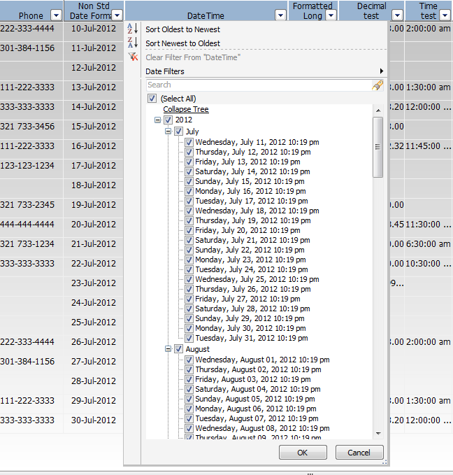

Custom Filter with Datepicker for Date column
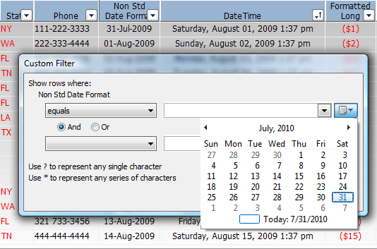
Custom Filter partial list of filter options
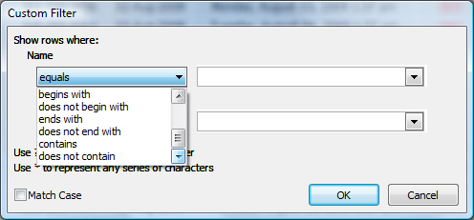

Pre-defined Date column Filter Options
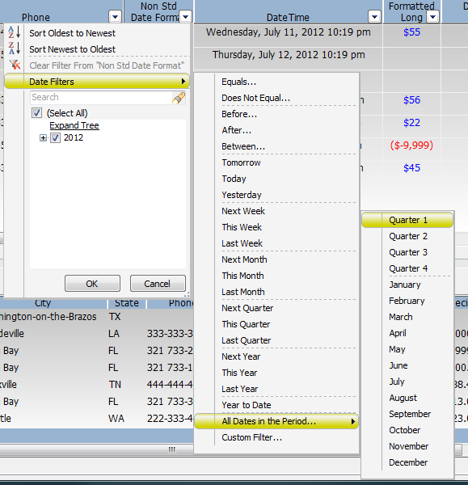
Expression-Formatted Text, color change based on IF(Mod(Getrow(),2)=0,”[RED][General]”,”[BLUE][General]”
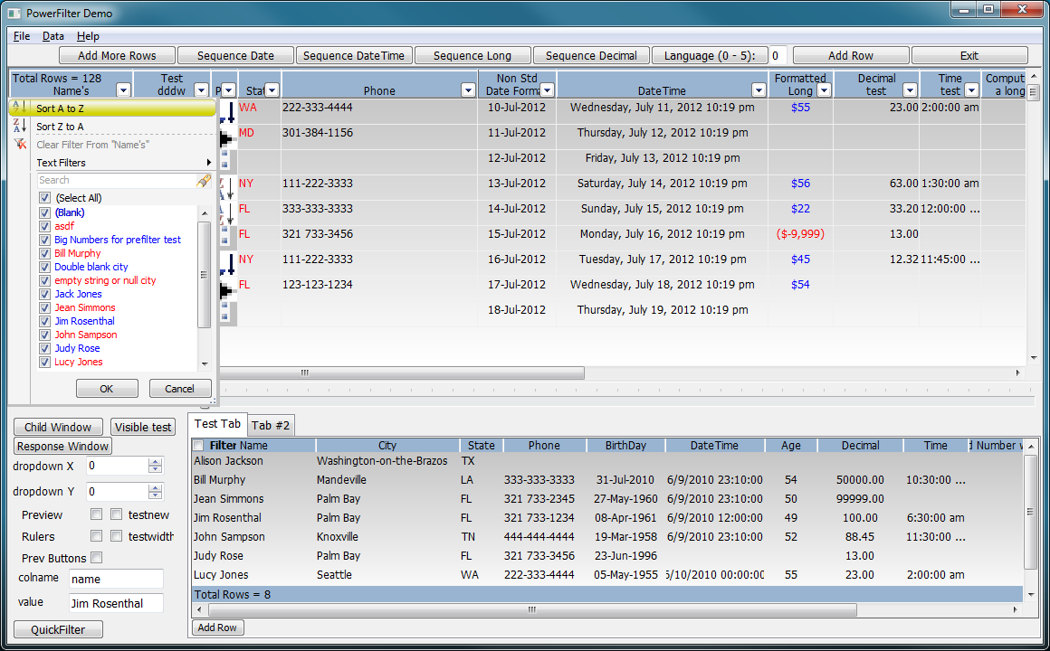

Custom Filter showing Column Formatting included in dropdown list
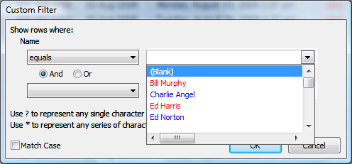
Example showing expression-based formatting, numeric pre-defined filter options, and Tooltip displaying description of current filter. List of values also shows which items are included (checked) based on current filter:
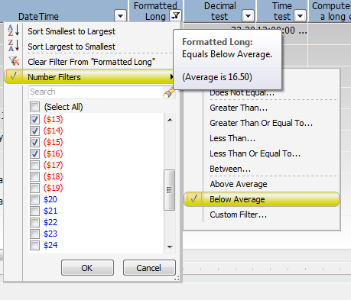

PowerFilter Version 2.0 - Jul 10, 2013
- of_SetBackgroundColor function to optionally set Background Color
- of_SetFontColor function to optionally set Font Color
- of_SetFontName function to optionally set Font Name
- of_Set_Post_Filter_Event to identify an event on a parent object to execute after filter is applied
- Search Bar added to Dropdown, dynamically filters the dropdown list as you type to include only items matching what you type
- Incrementally add Search results to previous results with Search Bar
- Expand/Collapse Date Tree option added to fully expand and collapse the branches of the date tree
- Improved Performance for high data volume. Code performance improved, and optional parameters to limit the time spent building the dropdown list
- Resize from side and bottom, not just corner of the dropdown list
- Sort Descending bug below PB 11.5 fixed
- Dropdown placement and sizing for smaller window height.
- Secondary options lists resize and scroll if needed to fit window height
- Refined look
- Tested to work with 96 and 120 dpi.
- Groupcalc() after filter applied
- Apostrophes in Header Text handled
- Button x coordinate bug fixed (integer changed to long for very wide datawindows)

